CIT 591 HW6

Xin Xu, Keqin Zhou

Art Searcher-User Manual

1. To run the Art Searcher app, run GUI.java under [file path]

[insert path image]

1. On the app, there is an input box and a search button. The user can enter any artist in the format of “LAST, first” in the box and click on the button to search for the art work of that artist.

[insert search page with Monet]

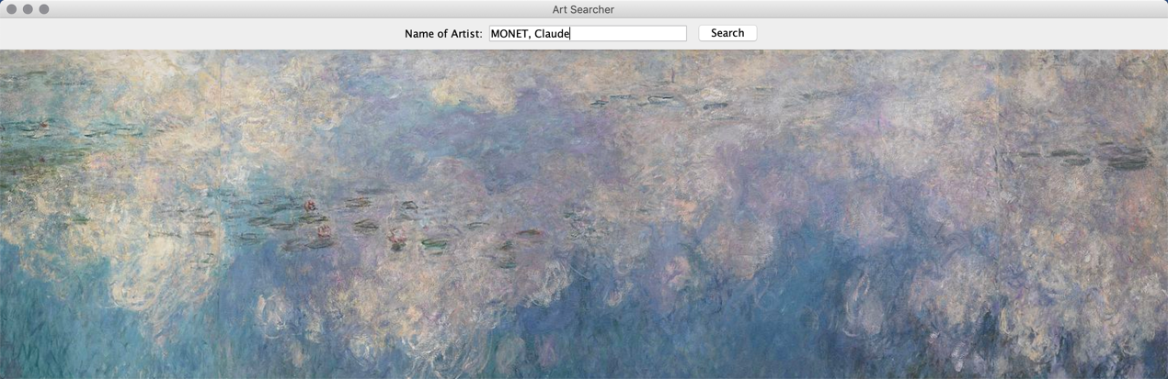

1. When the user clicks the “Search” button, the program runs a search algorithm of all the paintings in the database. If the artist is in the data base, all the titles of the artworks of the artist are displayed. If not, an error message will show up.

[insert “names of work” image of Monet]

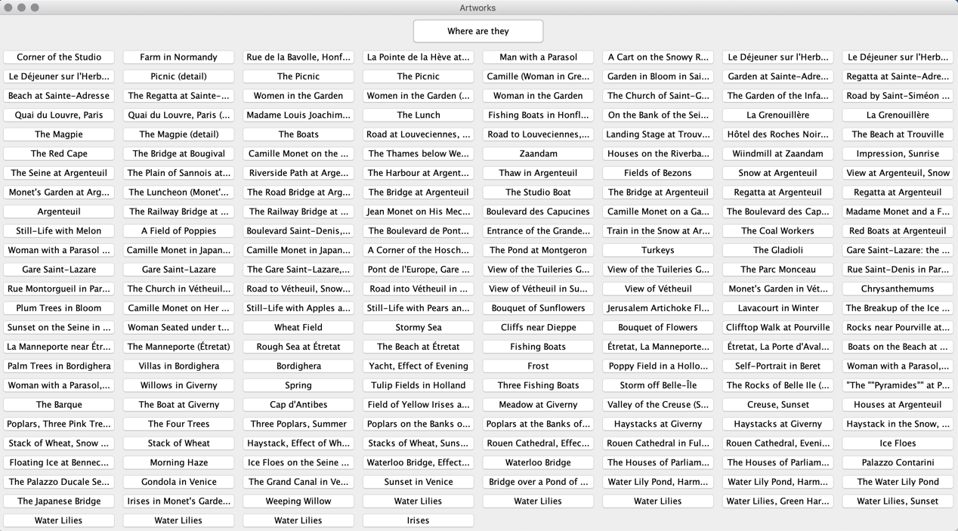

Error message:

[insert error message window]

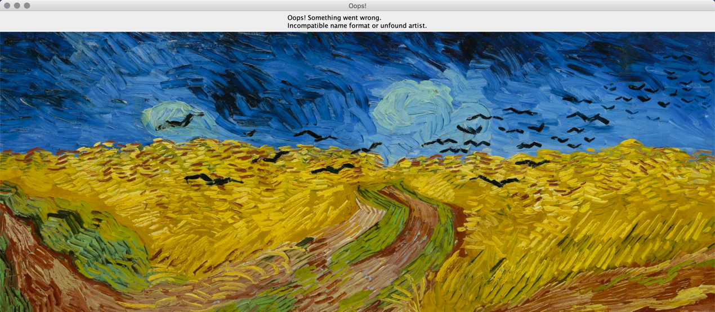

1. The user can click on any of the artwork and the app will display the image and detailed information of the artwork.

[insert info page]

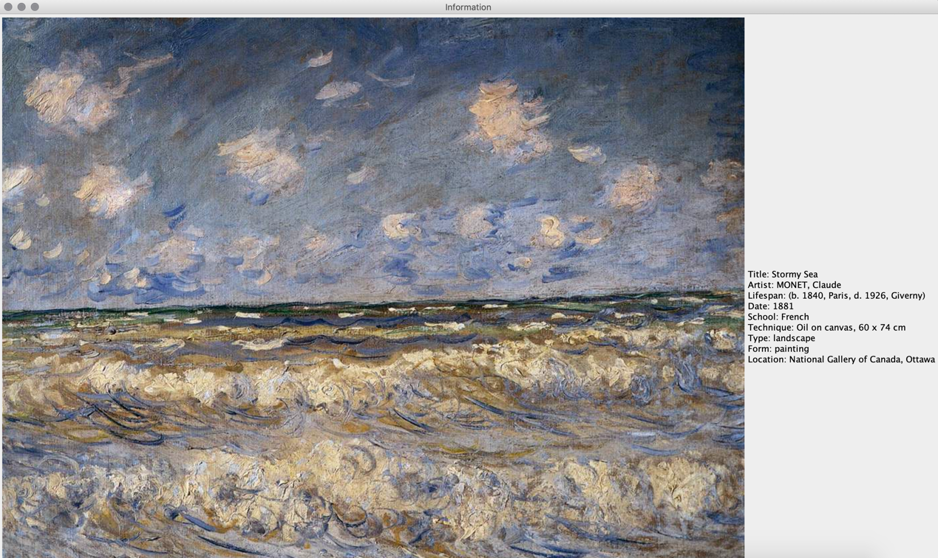

1. Along with all the work displayed, on the top of the window, there is a “Where are they” button. When the user clicks the button, a Google Map page will pop up in the default browser. The map will show the locations of at most 10 paintings due to Geocode limits and the user can zoom in using the “+/-” button on the bottom right. The user can click on the marker to see which artworks are exhibited at the location.

[insert Google Map example]

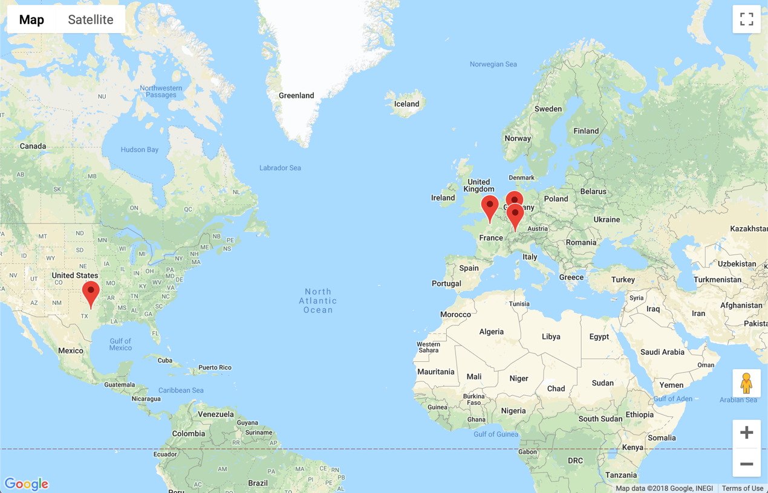

1. If there are less than 10 artworks displayed, then the map will display a message that says [message]. Note that the message may come up multiple times.

[insert Google Map message page]

